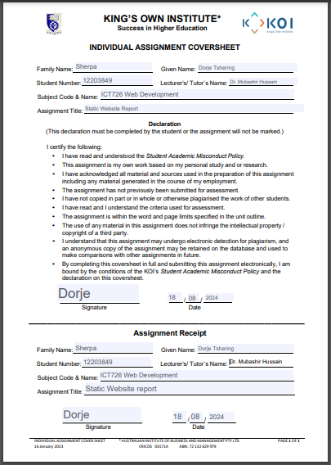Contents

Wanderlust Travels: Website Development Report 3

1.Introduction: 3

Business Overview 3

Website Structure: 3

Home Page: 3

About Page(about.html 3

Service Page(service.html): 3

Contact Page(contact.html): 3

Additional Pages: 3

Design Decisions and Challenges: 4

Challenges: 4

2. AI Assistance Declaration: 4

AI Tools Used: 4

Side-by-side comparison: 4

3. Accessibility and Usability: 5

Accessibility: 5

Usability: 5

4. Screenshots and Visuals: 6

Home Page: 6

About Page: 7

Contact Page: 8

Service Page: 9

Paris.html Page: 10

Bali.html Page: 11

Newyork.html Page: 12

Wireframes to final design: 12

5. Reflection and Learning: 13

# Wanderlust Travels: Website Development Report

# 1.Introduction:

## Business Overview

Wanderlust Travels is your ticket to fresh experiences. At Wanderlust Travels, we have a strong passion for tailored travel experiences that move you to some of the world's most captivating places. Whether you are thinking of an exciting adventure or a romantic retreat, our website can be your one stop for searching for custom travel packages, getting inspired by breathtaking locations, and contacting us to start organizing your ideal trip. Let us assist you in realizing this travel dream.

## Website Structure:

The website consists of the following pages:

Home Page: The index page is a home page where I have introduced the Wanderlust Agency. I have also put some travel destinations. I have saved the page as index.html.

About Page(about.html): This is an about page. I have put the detailed information about the website where I have included about its mission and values.

Service Page(service.html): This is a service page where I have put some of the destinations. I also have put some packages including Paris, Bali and New York packages.

Contact Page(contact.html): Here I have put the details of our location, our email, contact number and our business time.

## Additional Pages:

I have also made 3 additional pages. They are paris.html, bali.html and newyork.html. These all three pages shows the package.

## Design Decisions and Challenges:

So, while building this website, I have decided to make the website visually appealing. Also I have tried to make it easy to navigate.

I tried to choose the vibrant color which can be used to evoke a sense of adventure.

I also have used high-quality images for the destinations to attract visitors.

Challenges: Some of the challenges I have faced were to ensure the design was fully functional, also optimizing images for faster loading.

# 2. AI Assistance Declaration:

## AI Tools Used:

While developing this website, I did use the AI tools such as chatgpt to help me understand the desired functionality for the website. I used chatgpt when I was stuck while writing some code. Other than chatgpt, I also researched from w3s school to write some code.

## Side-by-side comparison:

|  |  |
| --- | --- |
| **AI generated draft** | **Final customized version** |
| -HTML functionality | - Enhanced contents and simple form validation. |
| -Use of various classes, divisions. | - Giving the unique look for the used classes and divisions |

# 3. Accessibility and Usability:

## Accessibility:

-I tested this website to ensure that all interactive elements are accessible via keyboard(keyboard navigation).

-And also to ensure readability for all users, I have chosen text and background colors to meet the contrast ratio.

## Usability:

-I have also made the nav bar where the navigation menu is straightforward. This shows clear links to all major pages such as index page, contact page, service page and about page.

# 4. Screenshots and Visuals:

## Home Page:

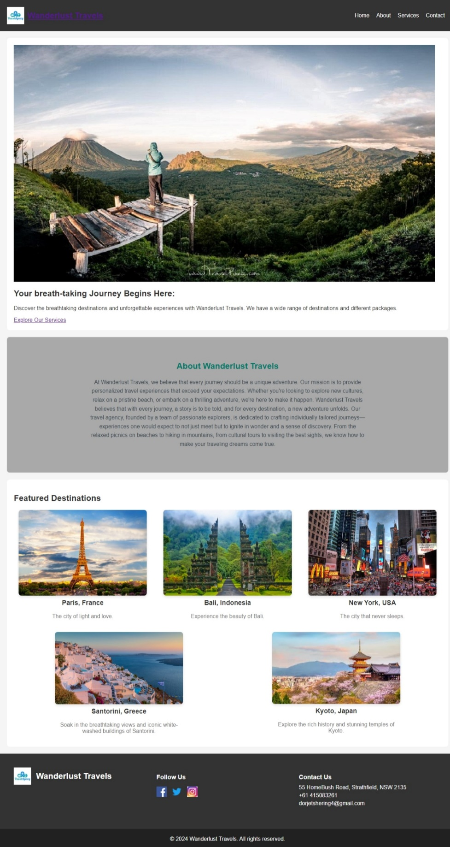

## About Page:

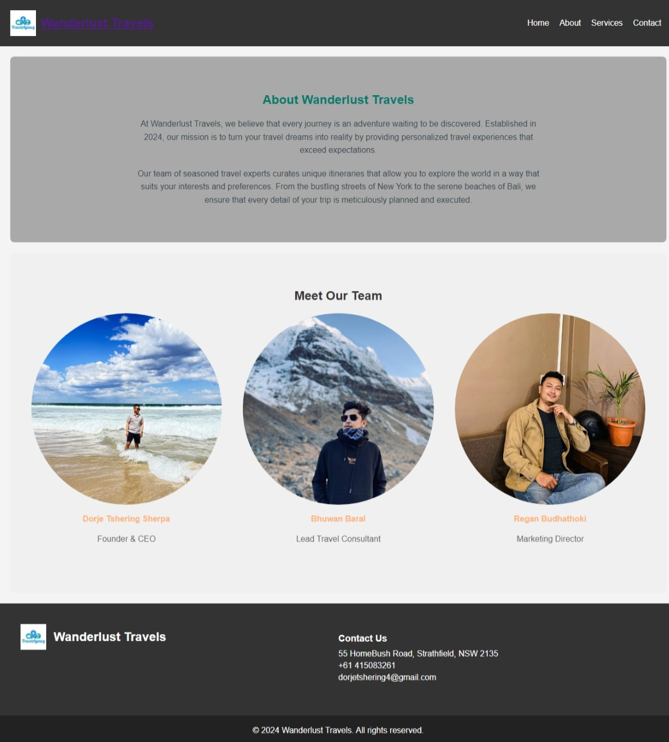

## Contact Page:

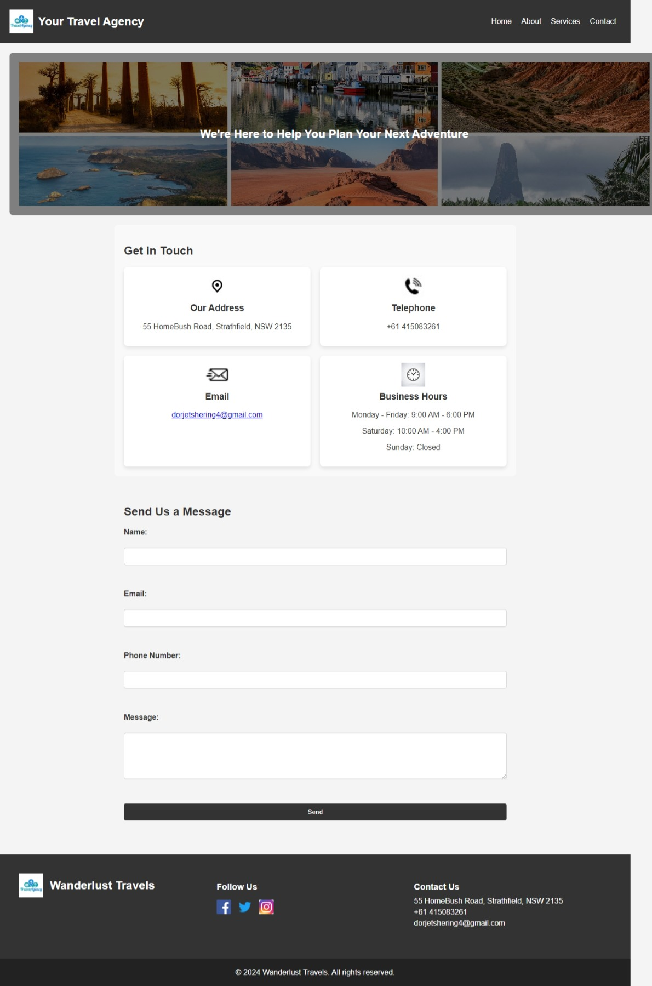

## Service Page:

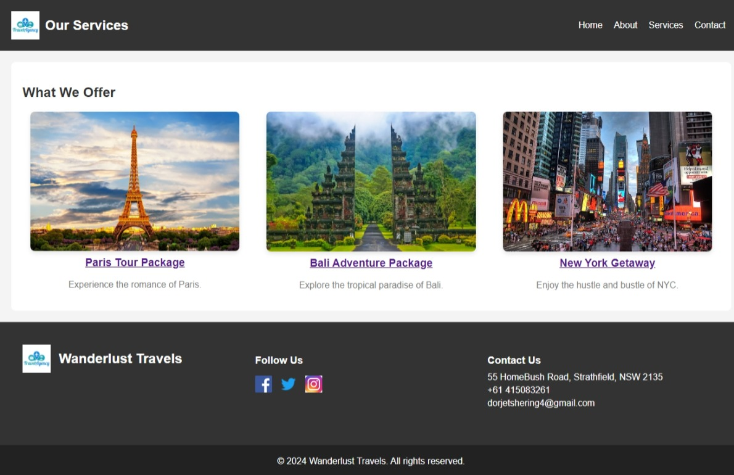

## Paris.html Page:

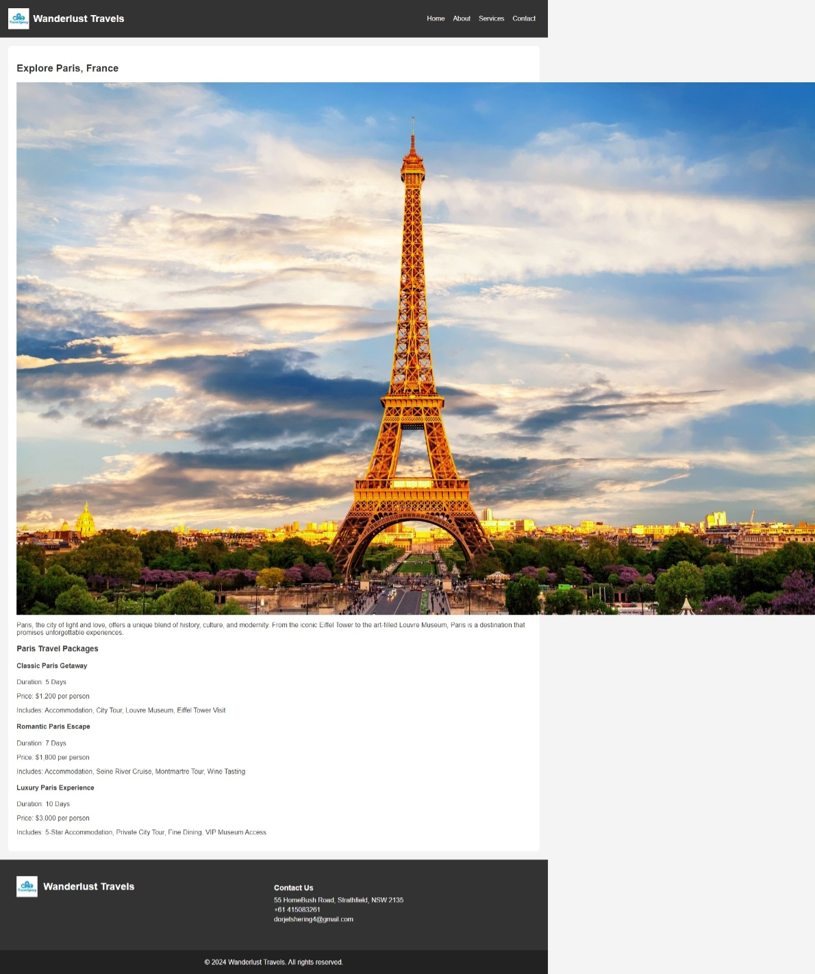

## Bali.html Page:

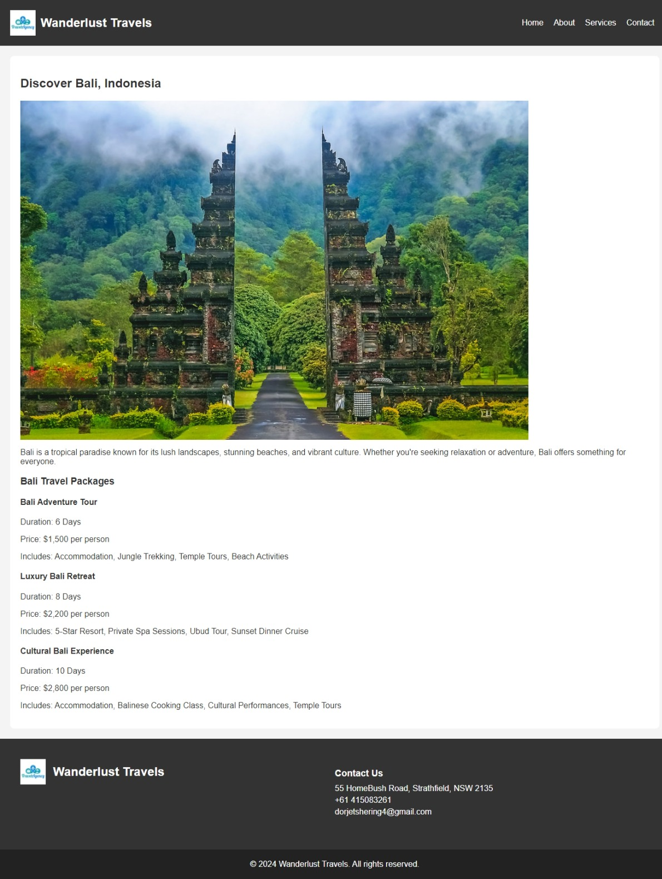

## Newyork.html Page:

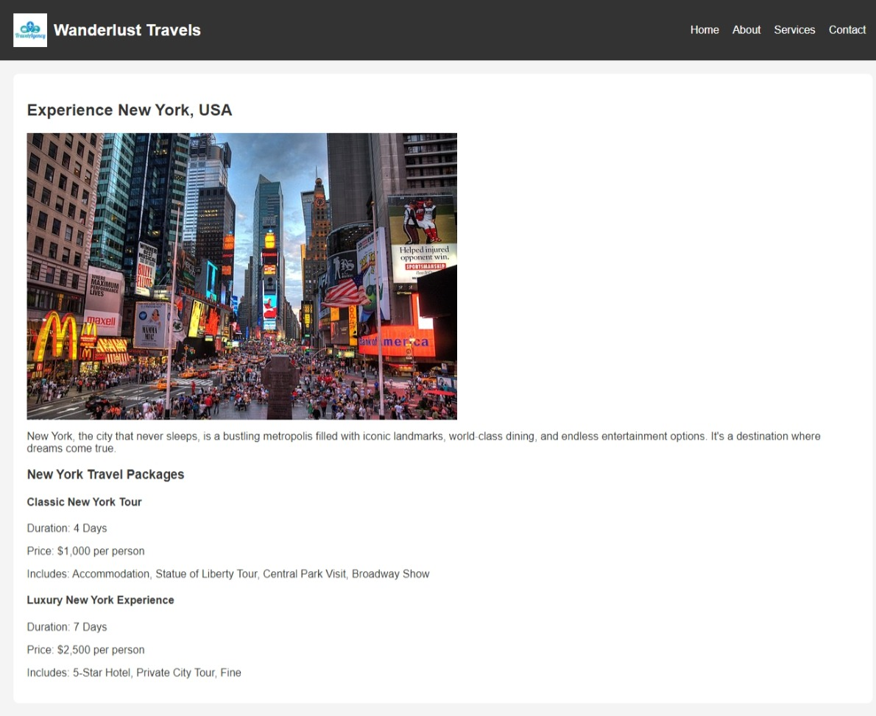

## Wireframes to final design:

I created some initial wireframes to outline the structure of each page. So, to develop the final design, I incorporate different feedbacks and adjustments.

# 5. Reflection and Learning:

Developing this website, (Wanderlust Travels), I gained a valuable learning experience. I understood the importance of planning, design consistency and user-centered development. I think developing this website helped me in increasing my knowledge on HTML and CSS more.